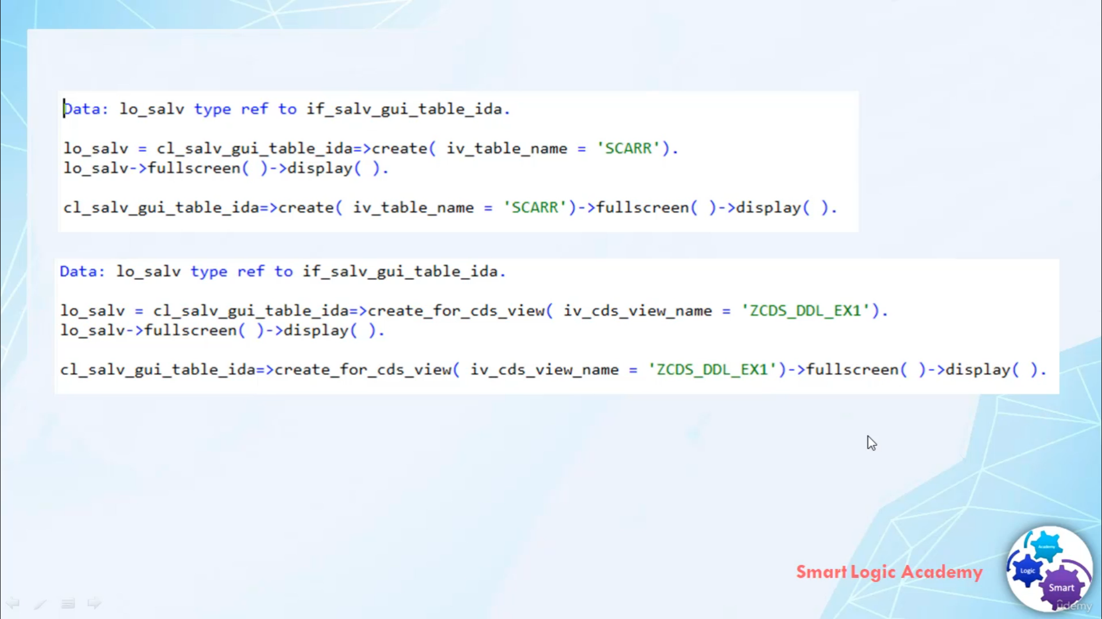

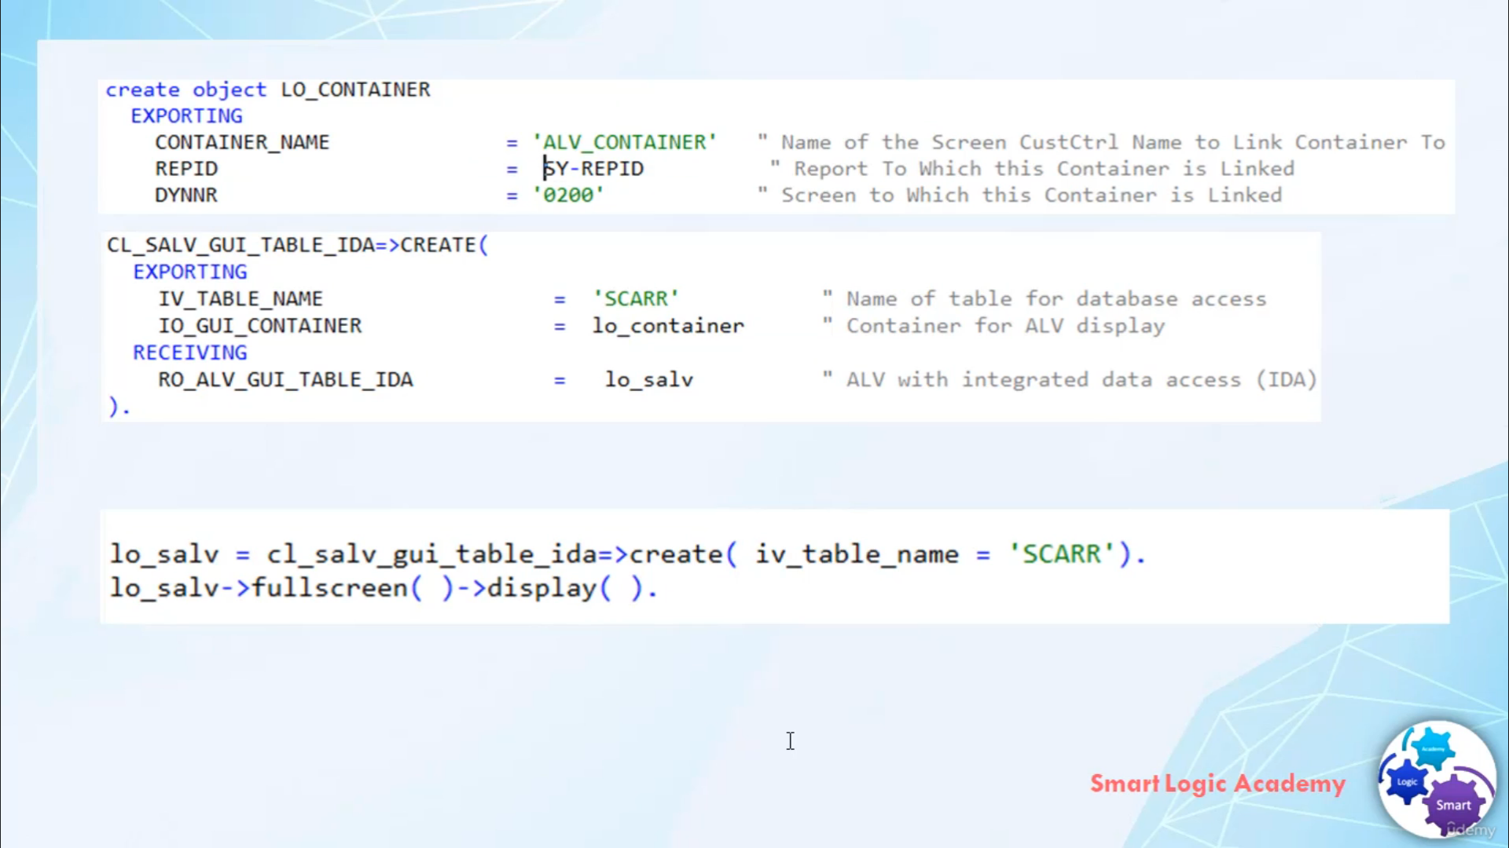The example in the figures shows how you can instantiate ideas to different effective methods exist

depending on the datasource, the evidence to show the data from.

Use metal cleared for database tables, database views, and use metal cleared for serious view to specify

cities through rather than passing any dinner table containing data to be displayed only the name of

database table authorities who need to be supplied via input parameter.

Getting Mr. Chinning.

The intercutting becomes a single ennab statement.

There are two different ways to invoke the display of idea.

You can use the input barometer, I would use a container of metal to create to deal with it in the

instance to the container control.

In that case, you have to create an instance of the container control class before you instantiate

the with idea class.

And with it also offers a stand alone display in this case, you do don't have to instantiate a container

control, you have to simply call meter full screen of your elby with iodines tons and then metal display.

That's it for now, I hope you understood it.

Have a nice day.